Plan to Build Cartesian Robot

The Cartesian robot can be divided into 2 main systems: Mechanical and Electrical (Control) Systems.

Mechanical System:

1. Build general frame using T-slot aluminum profiles. The Frame will also work as the rails for the Y coordinate of the robot.

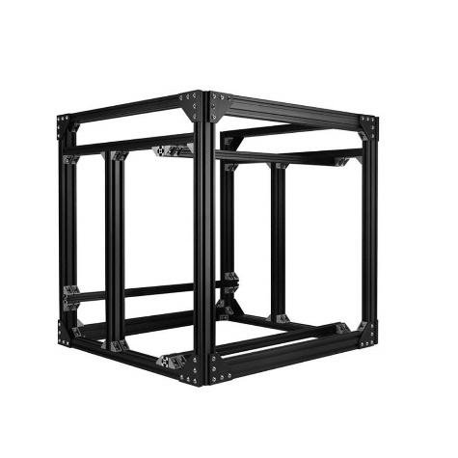

1. Install T-slot support plates and linear actuator system on the frame for the motion on the Y axis. The support plates will work as the supports for the gantry or X coordinate of the robot.

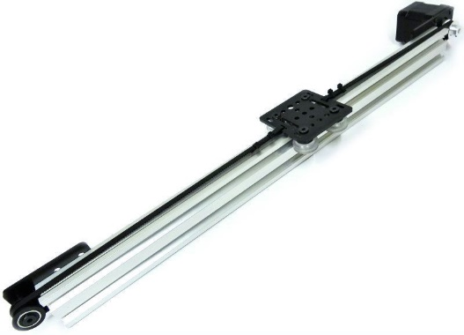

1. Install T-slot support plates on the gantry and linear actuator system for motion on the X axis. It will be used as the support for the motion along the z axis.
2. Design and build the z axis using a lead screw actuator.

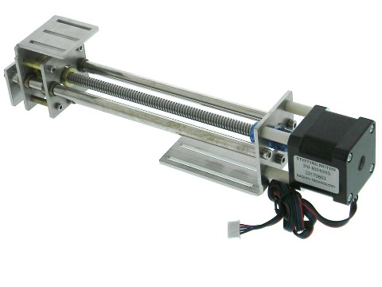

Electrical System:

1. Obtain and read data sheets for the stepper motors and drivers.
2. Get familiarized with the Velocio 222 Programmable Logic Controller (PLC) and the software VBuilder. It is recommended to program the stepper motor using machine states and flow diagrams.
3. Put together the control system. (PLC, driver, stepper motor and power supply)
4. Learn how to control the stepper motor using the PLC.
5. Create a user interface to control the stepper motor using VFactory.
6. Install the control systems on the X and Y Coordinates of the robot.
7. Install limit switches on the X and Y Coordinates of the robot.
8. Program the PLC in order to achieve motion on the X and Y coordinates.
9. Create sequence to “home” the X and Y coordinates.
10. Create user interface to control motion along the X and Y coordinates.
11. Install the control system on the Z axis.
12. Install limit switches on the Z axis.
13. Include motion on the Z axis on the PLC program.
14. Create sequence to home the Z axis.
15. Include control of the Z axis on the user interface.

Steps 1 – 4 of the Mechanical System and Steps 1 – 5 of the Electrical System can be done simultaneously. Steps 6 – 10 of the electrical System can only be done after finishing step 3 of the Mechanical System. Steps 11 – 15 of the Electrical System can only be done after finishing step 4 of the mechanical system.